**EXPERIMENT 1**

**NAME: Vishal Shashikant Salvi UID: 2019230069**

**CLASS: TE COMPS BATCH: C**

**DATE:**

**Aim:** To study the core elements of UXD planes and design prototype for the given problem.

**Theory:**

The core elements of User Experience Design (5 planes) are:

There are five dependent layers, each level builds on the level before it, and they start with abstract level towards concrete one (from bottom to top).

## **Strategy**

The reason for the product, application or the site, why we create it, who are we doing this for, why people are willing to use it, why they need it. The goal here is to define the user needs and business objectives.

I create this prototype for passenger those who want to book taxi as well as can search taxi nearby their location so they can select type of taxi and taxi driver experience also.

This could be done through **Strategic Research Process**, where you interview users, and all stakeholders in addition to review the competing products or companies.

## **Scope**

Defines the functional and content requirements. What are the features, and content contained in the application. The requirements should fulfill and be aligned with the strategic goals.

Functional Requirements It’s the requirements about the functions, or features in the product, how features work with each other, and how they interrelate with each other. These features are what user need to reach the objectives.

Content Requirements It’s the information we need in order to provide the value. Information like text, images, audio, videos, …etc. Without defining the content, we have no idea about the size or time required to complete the project.

**Scope:**

* **Function Requirements:**
* Tracking Realtime
* Login with number
* OTP verification
* Search Taxi
* **Content Requirements:**
* Phone No
* Source & Destination
* Review

## **Structure**

Defines how user interact with the product, how system behave when user interact, how it’s organized, prioritized, and how much of it. Structure is split into two components, Interaction Design & Information Architecture.

Interaction Design Given the functional requirements, It defines how user can interact with the product, and how the system behaves in response to the user interactions.

* In this application user need to enter phone no to book taxi after that OTP will send to user and verification take place. Also, when user enter source and destination after that system give response that select which type of taxi you want.
* Information Architecture Given the content requirements, It defines the arrangement of content elements, how they are organized, to facilitate human understanding.

## **Skeleton**

Skeleton determines the visual form on the screen, presentation and arrangement of all elements that makes us interact with the functionality of the system that exist on the interface. Also how the user moves through the information, and how information is presented to make it effective, clear, obvious.

**Wireframes** are widely used to create a visual format, which is a Static diagram that represent a visual format of the product, including content, navigation and ways for interactions.

Skeleton is split into three components Interface Design, Navigation Design, & Information Design.

* Interface Design presenting and arranging interface elements to enable users to interact with the functionality of the system.
* Navigation Design how to navigate through the information using the interface.
* Information Design defines the presentation of information in a way that facilitates understanding.

## **Surface**

It’s the sum total of all the work and decisions we have made. It determines how does the product will look like, and choosing the right layout, typography, colors, …etc.

In Surface, we are dealing with Visual Design (Sensory Design), It’s concerned about the visual appearance of content, controls, which gives a clue of what user can do, and how to interact with them. It should make things easier to understand, increase cognitive ability to absorb what users see on the screen.

**Problem Statement:**

In today’s era, everyone wants convenience and comfort in daily life activities but everywhere, it is not possible. Travelling is also a major part of day-to-day activities and in same case also, people wants same comfort assistance in whole journey.

Taking this statement, I came to the solution that will provide the comfort as well as secure journey.

The objective of taxi booking is to automate vehicle rental and reservation. So, customers do not need to call & spend unnecessary time in order to reserve preferred vehicle. They can go online and reserve any preferred kind of taxi they want, which is available at that time.

**Prototype Design:**

Front Phase of Book Your Ride as well as Tracking Realtime Location of Passenger.

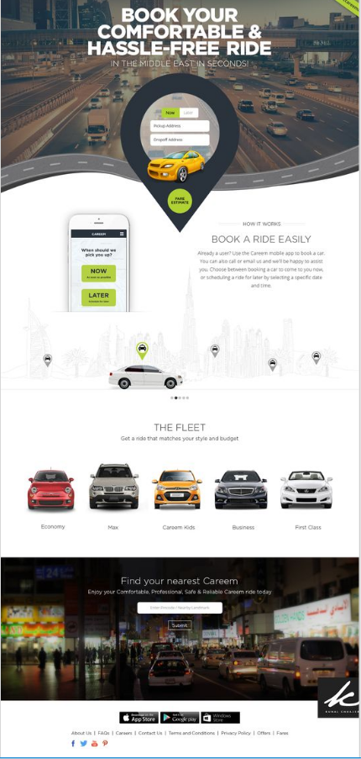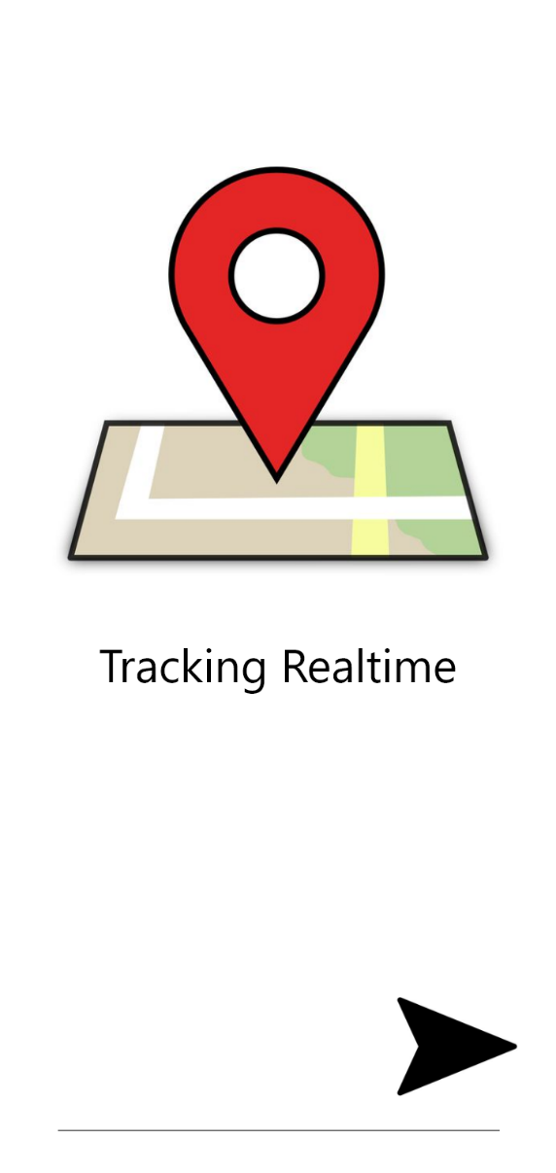

Passenger need to on location from device and after that Taxi Booking will started.

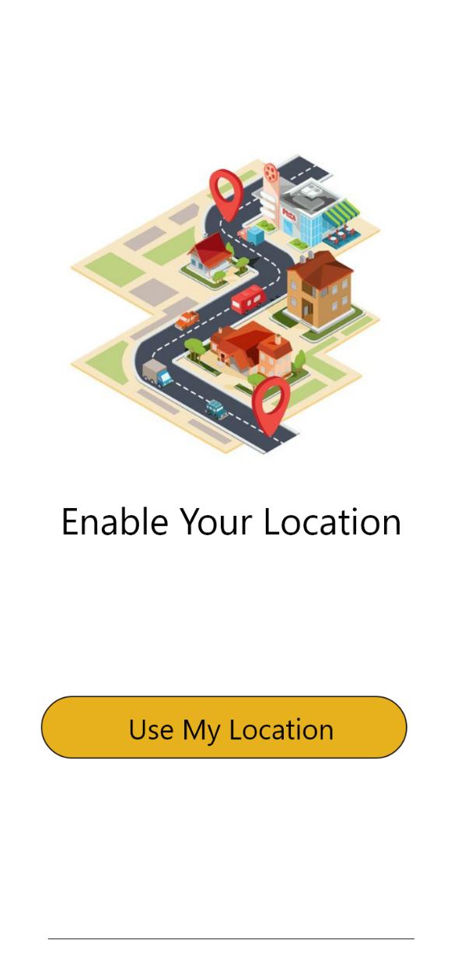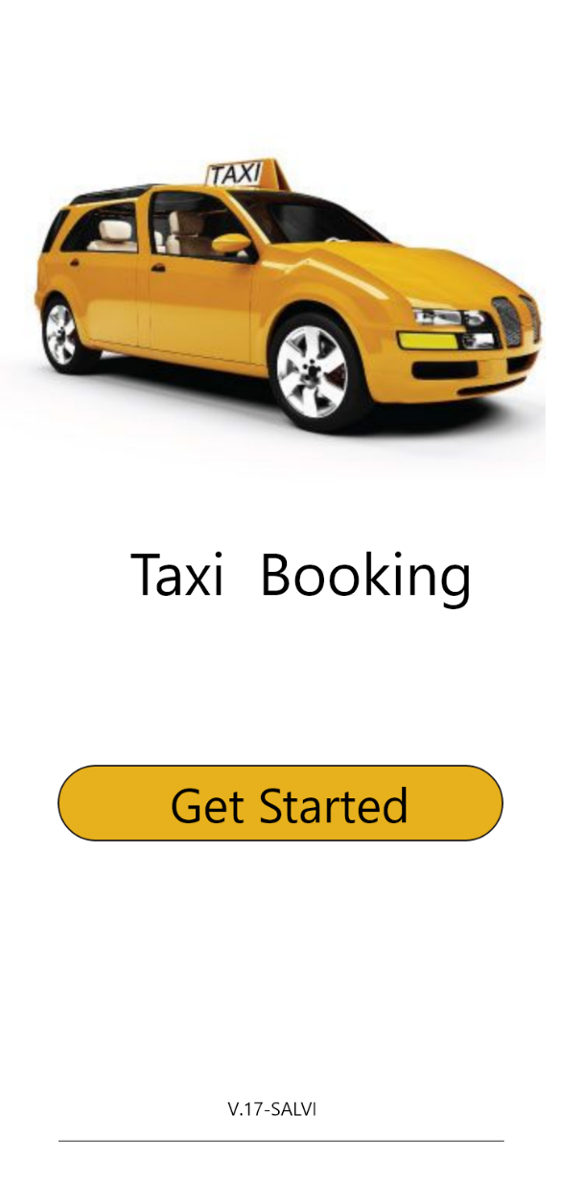

After that passenger enter phone no to log in to get OTP for further process.

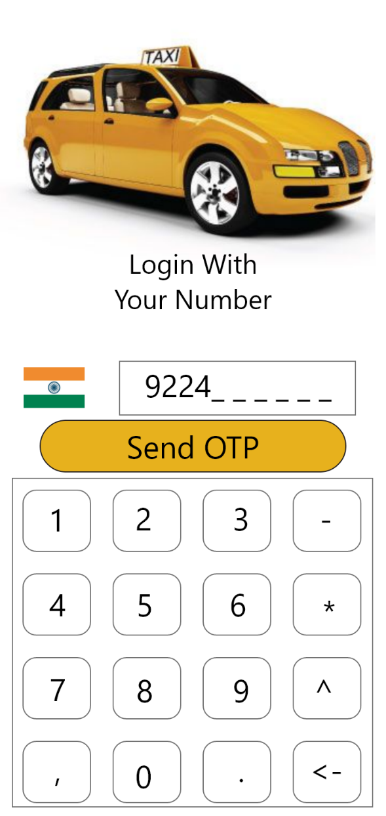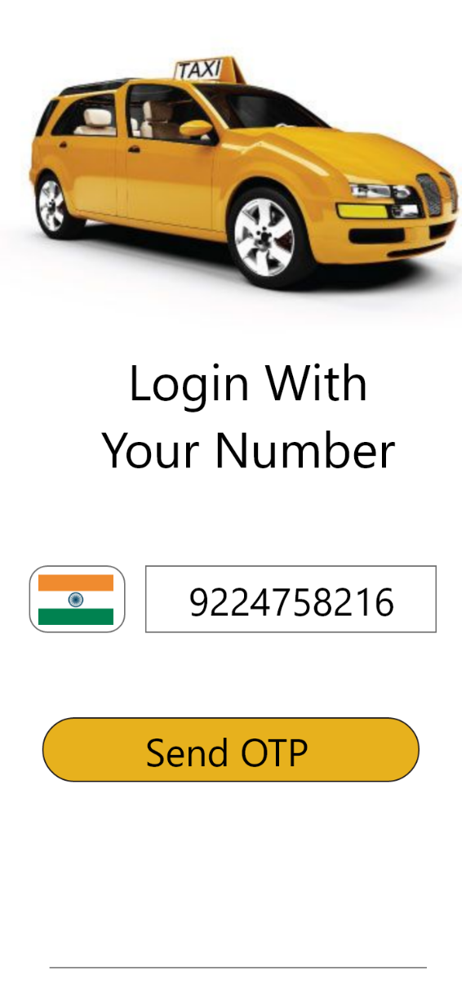

OTP which is sent on respective phone no that will verified.

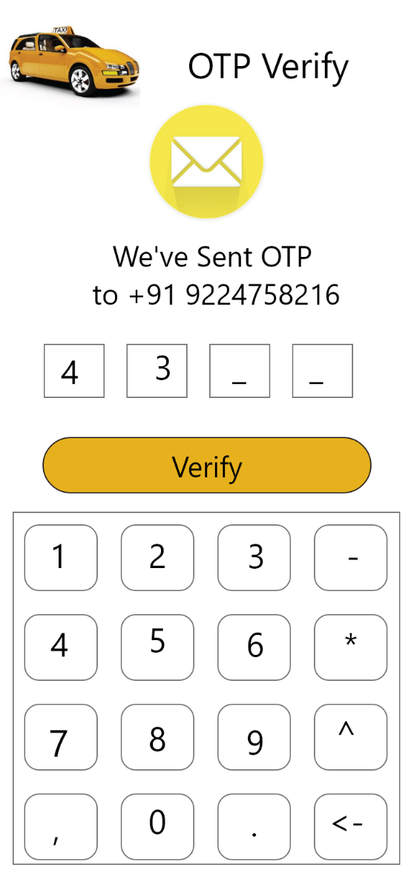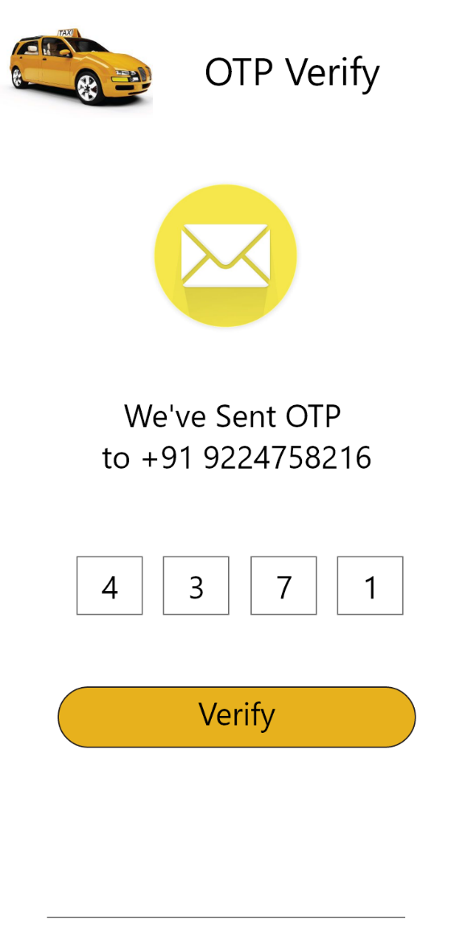

Welcome Screen Visible after Verification Process.

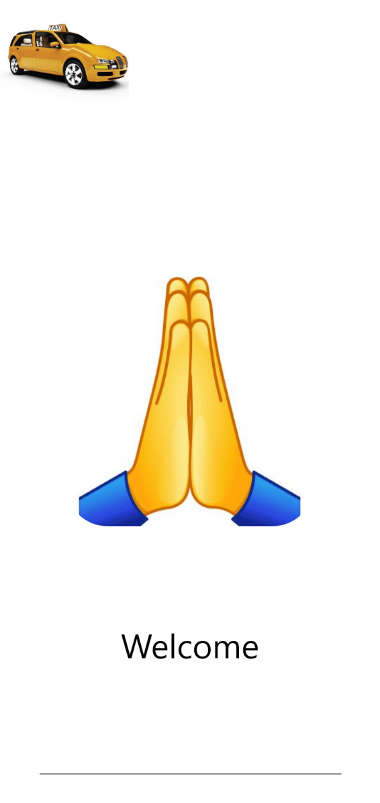

Now User get their location where he/she is currently located.

User can enter Source as well as destination where he/she wants to go.

Also, user select which type of taxi he/she want.

User Book that taxi.

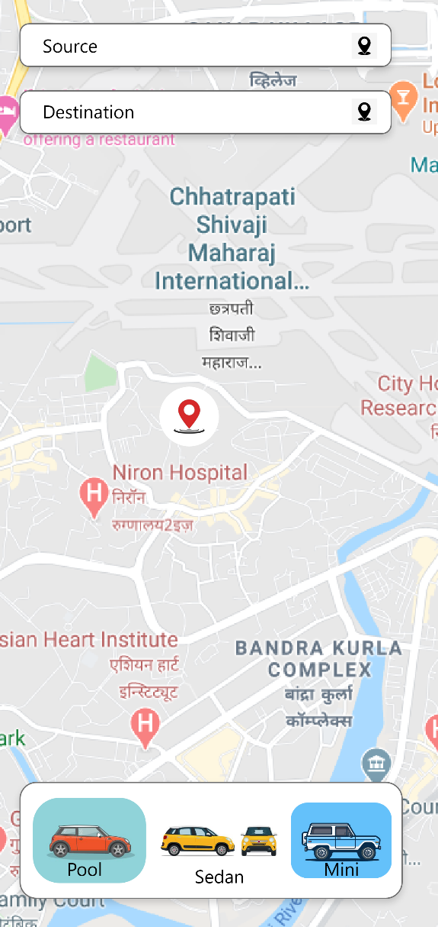 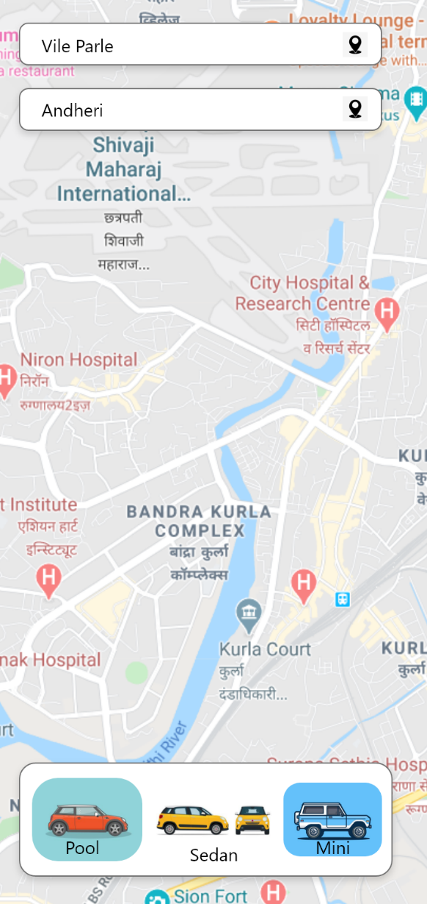

User get taxi as well as route to reach the destination.

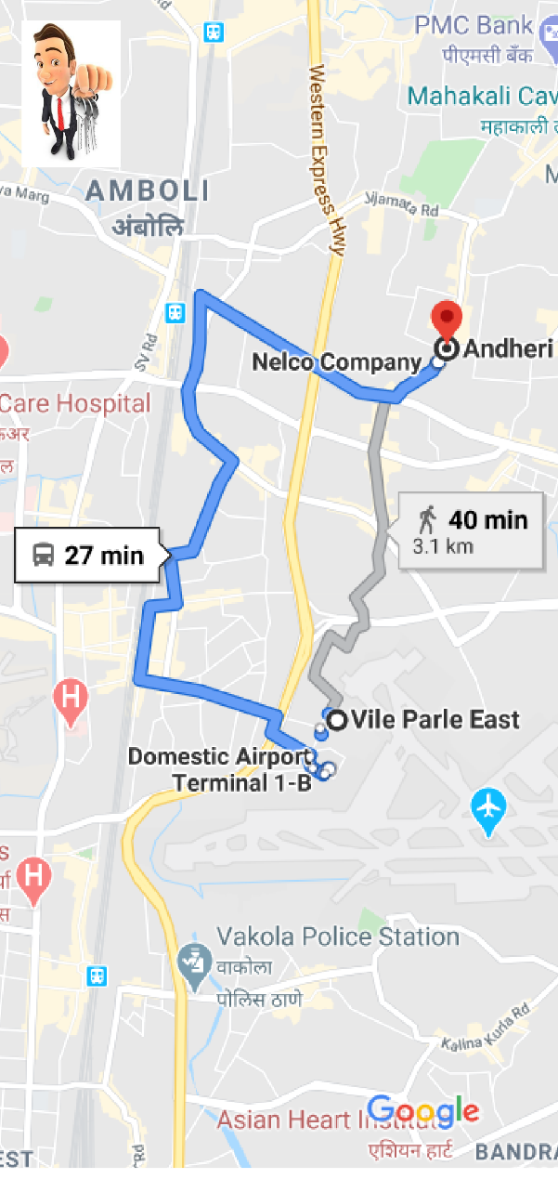 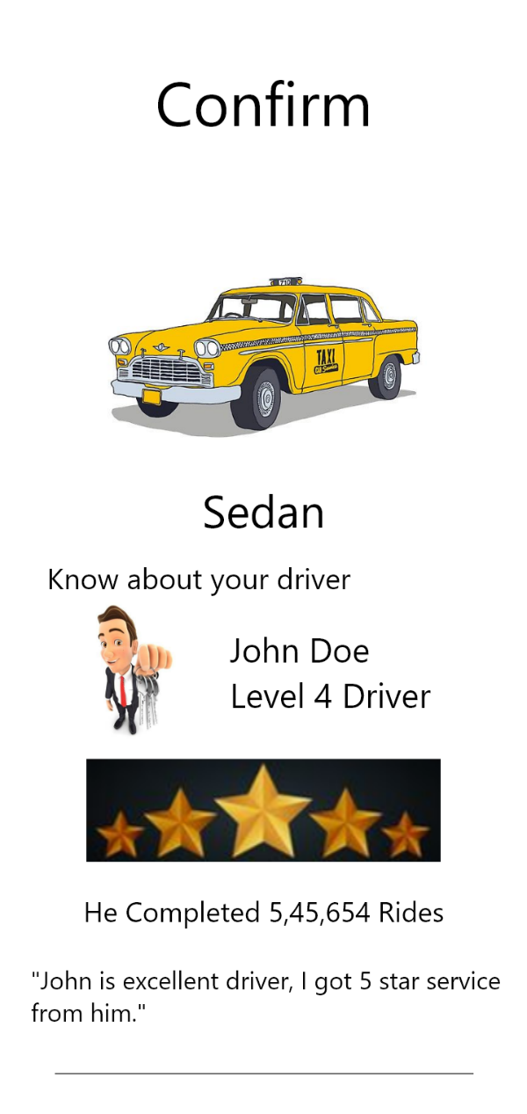

**Conclusion:**

User experience design is the process of creating products that provide meaningful and relevant

Experience to users. So, I learn that how it focuses on having deep understanding of users, what

they need, what they Value, their abilities, and also their limitations.